**MINISTRY OF EDUCATION AND TRAINING**

**FPT UNIVERSITY**

Capstone Project Report 4

**The Laboratory Tests   
Management System**

|  |  |
| --- | --- |
| **Group 6** | |
| **Group members** | Bạch Minh Đức – SE61791  Châu Minh Ý– SE61419  Trần Tuấn Dũng – SE61982  Nguyễn Hữu Lâm – SE61234 |
| **Supervisor** | Hồ Hoàn Kiếm |
| **Ext. Supervisor** | N/A |
| **Capstone Project Code** | eLTMS |

- Ho Chi Minh City, 14 September 2018 -

# Table of Contents

Table of Contents 2

**Software Design Description** 3

**1.** **Design Overview** 3

**2.** **System Architectural Design** 4

**3.** **Component Diagram** 5

**4.** **Details Description** 7

4.1. Class Diagram 7

4.2. Class Diagram Explanation 8

4.2.1. Account 8

4.2.2. Feedback (removed) 9

4.2.3. Manager (removed) 9

4.2.4. ExportPaper 9

4.2.5. SupplyType 10

4.2.6. Patient (removed) 10

4.2.7. Employee (removed) 11

4.2.8. ExportPaperDetail 11

4.2.9. Supply 12

4.2.10. Appointment 12

4.2.11. Receptionist (removed) 13

4.2.12. Nurse (removed) 13

4.2.13. Warehouse Keepper (removed) 13

4.2.14. ImportPaperDetail 14

4.2.15. Department (removed) 14

4.2.16. Hospital (removed) 14

4.2.17. Doctor (removed) 15

4.2.18. Sample 15

4.2.19. SampleGetting 16

4.2.20. ImportPaper 16

4.2.21. Lab Technician (removed) 16

4.2.22. Lab Test 17

4.2.23. SampleGroup 17

4.2.24. HospitalDepartmentMapping (removed) 17

4.2.25. HospitalSuggesting (removed) 18

4.2.26. ResultPaper (removed) 18

4.2.27. TestProfileLabTestMapping (removed) 19

4.2.28. TestProfile 19

4.3. Interactive Diagram 21

4.3.1. Guest 21

4.3.1.1. <Guest> Make Appointment 21

4.3.2. Patient 22

4.3.2.1. <Patient> View Appointment’s Test Result 22

4.4. State Machine Diagram 23

**5.** **User Interface Design** 24

5.1. Web admin application user interface 24

5.1.1. Login Page 24

5.1.2. Hospital Receptionist Page 25

5.1.3. View Department Receptionist Page 27

5.1.4. View Nurse Page 30

5.1.5. View Laboratory Technician Page 32

5.1.6. View Doctor Page 35

5.2. Web application user interface 37

5.2.1. Login 37

5.2.2. Nav Bar 39

5.2.3. Home Page 39

5.2.4. Book Appointment 42

5.2.5. View list of Booked Appoinments 44

5.2.6. View Testing Result 45

5.3. Mobile application user interface 48

5.3.1. Login page 48

5.3.2. Register Account page 49

**6.** **Database Design** 50

6.1. Entity relationship diagram (ERD) 50

6.2. Entity dictionary 51

**7.** **Algorithms** 51

7.1. Slot Suggestion 51

7.1.1. Definition 51

7.1.2. Define problem 51

7.1.3. Solution 52

7.1.4. Complexity 52

7.1.5. Flowchart 53

# **Software Design Description**

## **Design Overview**

This document describes the technical and user interface design of Building the laboratory tests management system (eLTMS).

Document overview:

Section 2: gives an overall description of the system architecture design.

Section 3: gives component diagrams that describe the connection and integration of the system.

Section 4: gives the details design description which includes class diagram, class explanation, and sequence diagram to detailss the application functions.

Section 5: describes screens design.

Section 6: describes a fully attributed ERD.

Section 7: describes algorithms.

## **System Architectural Design**

Our system has been developed under the 3-layer architecture. The 3-layer architecture is different from the 3-tier architecture, because 3 components are separated logically (can be deployed on the same server), not physically (on different servers).

We choose this architecture for our system because of following advantages:

* **Speed of development:** a specific layer can be upgraded with minimal impact on the other layers.
* **Scalability**: By separating out the different layers we can scale each independently depending on the need at any given time.
* **Performance:** This allows you to load balance each layer independently, improving overall performance with minimal resources.

The 3-layer architecture consists of:

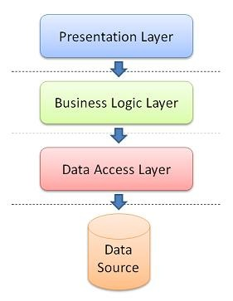

Figure 1 - System Architecture Design

* **Presentation Layer:** consists of the user interface. This user interface is often a graphical one accessible through a web browser or web-based application and which displays content and information useful to an end user.
* **Business Logic Layer:** contains the functional business logic which drives an application’s core capabilities.
* **Data Access Layer:** provides simplified access to data source.

## **Details Description**

### Class Diagram

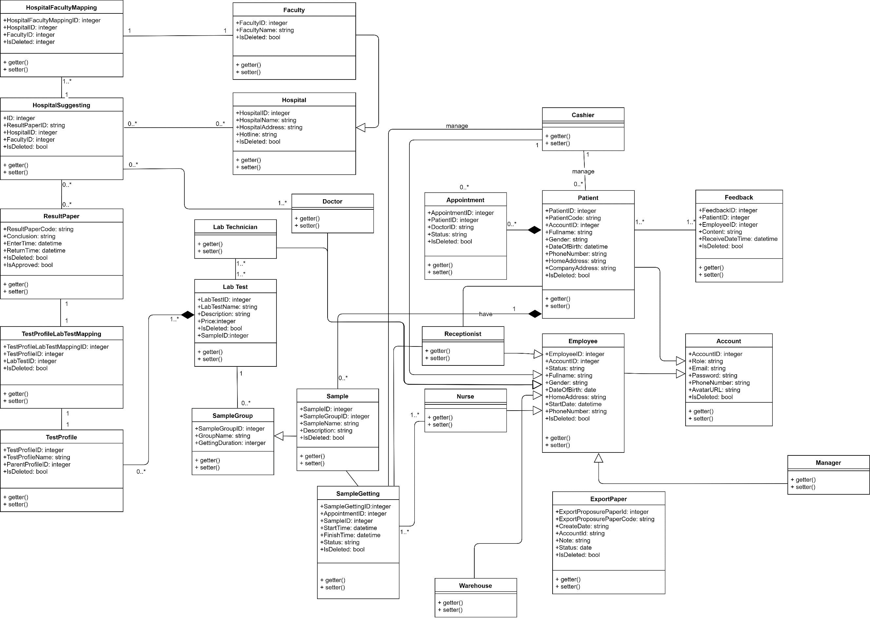

Figure 3 - Class Diagram

|  |  |
| --- | --- |
| CLASS DICTIONARY: DESCRIBE CLASS | |
| Class Name | **Description** |
| Patient | Patient |
| Employee | Employee |
| Feedback | Feedback |
| Account | Account |
| Manager | Manager |
| Receptionist | Receptionist |
| Appointment | Appointment |
| ExportPaperDetail | ExportPaperDetail |
| ExportPaper | ExportPaper |
| Supply | Supply |
| SupplyType | SupplyType |
| ImportPaperDetail | ImportPaperDetail |

Table 2 - Class Dictionary

### Class Diagram Explanation

#### Account

**Attribute**

|  |  |  |  |
| --- | --- | --- | --- |
| Attribute | Type | Visibility | Description |
| AccountID | integer | public | Unique identifier of an account |
| Role | string | public | Account’s Role |
| Email | string | public | Account’s Email |
| Password | string | public | Account’s Password |
| PhoneNumber | string | public | Account’s Phone number |
| AvatarURL | string | public | Account’s AvatarURL |
| IsDeleted | bool | public | Account’s IsDeleted |

Table 64 Account attribute explanation

**Method**

|  |  |  |  |
| --- | --- | --- | --- |
| Method | Return type | Visibility | Description |
| getter() | string | public | get attribute value |
| setter() | void | public | return value of attribute |
| checkLogin() | Boolean | public | check Account’s phone and password |
| register() | Boolean | public | register new user account |

Table 65 Account method explanation

#### Feedback (removed)

**Attribute**

|  |  |  |  |
| --- | --- | --- | --- |
| Attribute | Type | Visibility | Description |
| FeedbackID | integer | public | Unique identifier of a feedback |
| PatientID | integer | public | Feedback’s Patient |
| EmployeeID | integer | public | Feedback’s Employee |
| Content | string | public | Feedback’s Content |
| ReceiveDateTime | datetime | public | Feedback’s Date Receive |
| IsDeleted | bool | public | Feedback’s IsDeleted |

Table 66 Feedback attribute explanation

**Method**

|  |  |  |  |
| --- | --- | --- | --- |
| Method | Return type | Visibility | Description |
| getter() | string | public | get attribute value |
| setter() | void | public | return value of attribute |

Table 67 Feedback method explanation

#### Manager (removed)

**Attribute**

|  |  |  |  |
| --- | --- | --- | --- |
| Attribute | Type | Visibility | Description |
|  |  |  |  |

Table 68 Manager attribute explanation

**Method**

|  |  |  |  |
| --- | --- | --- | --- |
| Method | Return type | Visibility | Description |
| getter() | string | public | get attribute value |
| setter() | void | public | return value of attribute |

Table 69 Manager method explanation

#### ExportPaper

**Attribute**

|  |  |  |  |
| --- | --- | --- | --- |
| Attribute | Type | Visibility | Description |
| ExportProposurePaperId | integer | public | Unique identifier of an Export Paper |
| ExportProposurePaperCode | string | public | ExportPaper’s Code |
| CreateDate | datetime | public | ExportPaper’s CreateDate |
| AccountId | integer | public | ExportPaper’s Account |
| Note | string | public | ExportPaper’s Note |
| Status | string | public | ExportPaper’s Status |
| IsDeleted | bool | public | ExportPaper’s IsDeleted |

Table 70 Export Paper attribute explanation

**Method**

|  |  |  |  |
| --- | --- | --- | --- |
| Method | Return type | Visibility | Description |
| getter() | string | public | get attribute value |
| setter() | void | public | return value of attribute |

Table 71 Export Paper method explanation

#### SupplyType

**Attribute**

|  |  |  |  |
| --- | --- | --- | --- |
| Attribute | Type | Visibility | Description |
| SupplyTypeID | integer | public | Unique identifier of a Supply Type |
| SupplyTypeName | integer | public | SupplyType’s Name |
| IsDeleted | bool | public | SupplyType’s IsDeleted |

Table 72 Supply Type attribute explanation

**Method**

|  |  |  |  |
| --- | --- | --- | --- |
| Method | Return type | Visibility | Description |
| getter() | string | public | get attribute value |
| setter() | void | public | return value of attribute |

Table 73 Supply Type method explanation

#### Patient (removed)

**Attribute**

|  |  |  |  |
| --- | --- | --- | --- |
| Attribute | Type | Visibility | Description |
| PatientID | integer | public | Unique identifier of a Patient |
| PatientCode | string | public | Patient’s Code |
| AccountID | integer | public | Patient’s Account |
| Fullname | string | public | Patient’s Name |
| Gender | string | public | Patient’s Gender |
| DateOfBirth | datetime | public | Patient’s BirthDay |
| PhoneNumber | string | public | Patient’s Phone |
| HomeAddress | string | public | Patient’s Home Address |
| CompanyAddress | string | public | Patient’s Company Address |
| IsDeleted | bool | public | Patient’s IsDeleted |

Table 74 Patient attribute explanation

**Method**

|  |  |  |  |
| --- | --- | --- | --- |
| Method | Return type | Visibility | Description |
| getter() | string | public | get attribute value |
| setter() | void | public | return value of attribute |

Table 75 Patient method explanation

#### Employee (removed)

**Attribute**

|  |  |  |  |
| --- | --- | --- | --- |
| Attribute | Type | Visibility | Description |
| EmployeeID | integer | public | Unique identifier of an Employee |
| AccountID | integer | public | Employee’s Account |
| Status | string | public | Employee’s Status |
| Fullname | string | public | Employee’s Name |
| Gender | string | public | Employee’s Gender |
| DateOfBirth | datetime | public | Employee’s BirthDay |
| PhoneNumber | string | public | Employee’s Phone |
| HomeAddress | string | public | Employee’s Home Address |
| StartDay | datetime | public | Employee’s Start Day |
| IsDeleted | bool | public | Employee’s IsDeleted |

Table 76 Employee attribute explanation

**Method**

|  |  |  |  |
| --- | --- | --- | --- |
| Method | Return type | Visibility | Description |
| getter() | string | public | get attribute value |
| setter() | void | public | return value of attribute |

Table 77 Employee method explanation

#### ExportPaperDetail

**Attribute**

|  |  |  |  |
| --- | --- | --- | --- |
| Attribute | Type | Visibility | Description |
| ExportProposurePaperDetailId | integer | public | Unique identifier of an Export Paper Detail |
| ExportProposurePaperId | integer | public | ExportPaperDetail’s Export Proposer Paper |
| SuppliesId | integer | public | ExportPaperDetail’s Supply |
| Unit | string | public | ExportPaperDetail’s Unit |
| Quantity | integer | public | ExportPaperDetail’s Quantity |
| Note | string | public | ExportPaperDetail’s Note |
| IsDeleted | bool | public | ExportPaperDetail’s IsDeleted |

Table 78 Export Paper Detail attribute explanation

**Method**

|  |  |  |  |
| --- | --- | --- | --- |
| Method | Return type | Visibility | Description |
| getter() | string | public | get attribute value |
| setter() | void | public | return value of attribute |

Table 79 Export Paper Detail method explanation

#### Supply

**Attribute**

|  |  |  |  |
| --- | --- | --- | --- |
| Attribute | Type | Visibility | Description |
| SuppliesId | integer | public | Unique identifier of a Supply |
| SuppliesCode | string | public | Supply’s Code |
| SuppliesName | string | public | Supply’s Name |
| Unit | string | public | Supply’s Unit |
| Quantity | integer | public | Supply’s Quantity |
| Note | string | public | Supply’s Note |
| IsDeleted | bool | public | Supply’s IsDeleted |

Table 80 Supply attribute explanation

**Method**

|  |  |  |  |
| --- | --- | --- | --- |
| Method | Return type | Visibility | Description |
| getter() | string | public | get attribute value |
| setter() | void | public | return value of attribute |

Table 81 Supply method explanation

#### Appointment

**Attribute**

|  |  |  |  |
| --- | --- | --- | --- |
| Attribute | Type | Visibility | Description |
| AppointmentID | integer | public | Unique identifier of a Appointment |
| PatientID | integer | public | Appointment’s Patient |
| DoctorID | string | public | Appointment’s Doctor |
| Status | string | public | Appointment’s Status |
| IsDeleted | bool | public | Appointment’s IsDeleted |

Table 82 Appointment attribute explanation

**Method**

|  |  |  |  |
| --- | --- | --- | --- |
| Method | Return type | Visibility | Description |
| getter() | string | public | get attribute value |
| setter() | void | public | return value of attribute |

Table 83 Appointment method explanation

#### R**ecepti**onist (removed)

**Attribute**

|  |  |  |  |
| --- | --- | --- | --- |
| Attribute | Type | Visibility | Description |
|  |  |  |  |

Table 84 Receptionist attribute explanation

**Method**

|  |  |  |  |
| --- | --- | --- | --- |
| Method | Return type | Visibility | Description |
| getter() | string | public | get attribute value |
| setter() | void | public | return value of attribute |

Table 85 Receptionist method explanation

#### Nurse (removed)

**Attribute**

|  |  |  |  |
| --- | --- | --- | --- |
| Attribute | Type | Visibility | Description |
|  |  |  |  |

Table 86 Nurse attribute explanation

**Method**

|  |  |  |  |
| --- | --- | --- | --- |
| Method | Return type | Visibility | Description |
| getter() | string | public | get attribute value |
| setter() | void | public | return value of attribute |

Table 87 Nurse method explanation

#### Warehouse Keepper (removed)

**Attribute**

|  |  |  |  |
| --- | --- | --- | --- |
| Attribute | Type | Visibility | Description |
|  |  |  |  |

Table 88 Warehouse Keepper attribute explanation

**Method**

|  |  |  |  |
| --- | --- | --- | --- |
| Method | Return type | Visibility | Description |
| getter() | string | public | get attribute value |
| setter() | void | public | return value of attribute |

Table 89 Warehouse Keepper method explanation

#### ImportPaperDetail

**Attribute**

|  |  |  |  |
| --- | --- | --- | --- |
| Attribute | Type | Visibility | Description |
| ImportPaperDetailId | integer | public | Unique identifier of an Import Paper Detail |
| ImportPaperId | integer | public | ImportPaperDetail’s Import Paper |
| SuppliesId | integer | public | ImportPaperDetail’s Supply |
| Unit | string | public | ImportPaperDetail’s Unit |
| Quantity | integer | public | ImportPaperDetail’s Quantity |
| Note | string | public | ImportPaperDetail’s Note |
| IsDeleted | bool | public | ImportPaperDetail’s IsDeleted |

Table 90 Import Paper Detail attribute explanation

**Method**

|  |  |  |  |
| --- | --- | --- | --- |
| Method | Return type | Visibility | Description |
| getter() | string | public | get attribute value |
| setter() | void | public | return value of attribute |

Table 91 Import Paper Detail method explanation

#### Department (removed)

**Attribute**

|  |  |  |  |
| --- | --- | --- | --- |
| Attribute | Type | Visibility | Description |
| DepartmentID | integer | public | Unique identifier of an Department |
| DepartmentName | string | public | Department’s Name |
| IsDeleted | bool | public | Department’s IsDeleted |

Table 92 Department attribute explanation

**Method**

|  |  |  |  |
| --- | --- | --- | --- |
| Method | Return type | Visibility | Description |
| getter() | string | public | get attribute value |
| setter() | void | public | return value of attribute |

Table 93 Department method explanation

#### Hospital (removed)

**Attribute**

|  |  |  |  |
| --- | --- | --- | --- |
| Attribute | Type | Visibility | Description |
| HospitalID | integer | public | Unique identifier of a Hospital |
| HospitalName | string | public | Hospital’s Name |
| HospitalAddress | bool | public | Hospital’s Address |
| Hotline | string | public | Hospital’s Hotline |
| IsDeleted | bool | public | Hospital’s IsDeleted |

Table 94 Hospital attribute explanation

**Method**

|  |  |  |  |
| --- | --- | --- | --- |
| Method | Return type | Visibility | Description |
| getter() | string | public | get attribute value |
| setter() | void | public | return value of attribute |

Table 95 Hospital method explanation

#### Doctor (removed)

**Attribute**

|  |  |  |  |
| --- | --- | --- | --- |
| Attribute | Type | Visibility | Description |
|  |  |  |  |

Table 96 Doctor attribute explanation

**Method**

|  |  |  |  |
| --- | --- | --- | --- |
| Method | Return type | Visibility | Description |
| getter() | string | public | get attribute value |
| setter() | void | public | return value of attribute |

Table 97 Doctor method explanation

#### Sample

**Attribute**

|  |  |  |  |
| --- | --- | --- | --- |
| Attribute | Type | Visibility | Description |
| SampleID | integer | public | Unique identifier of a Sample |
| SampleGroupID | integer | public | Sample’s Group |
| SampleName | string | public | Sample’s Name |
| Description | string | public | Sample’s Description |
| IsDeleted | bool | public | Hospital’s IsDeleted |

Table 98 Sample attribute explanation

**Method**

|  |  |  |  |
| --- | --- | --- | --- |
| Method | Return type | Visibility | Description |
| getter() | string | public | get attribute value |
| setter() | void | public | return value of attribute |

Table 99 Sample method explanation

#### SampleGetting

**Attribute**

|  |  |  |  |
| --- | --- | --- | --- |
| Attribute | Type | Visibility | Description |
| SampleGettingID | integer | public | Unique identifier of a SampleGetting |
| SampleGroupID | integer | public | Sample’s Group |
| SampleName | string | public | Sample’s Name |
| Description | string | public | Sample’s Description |
| IsDeleted | bool | public | Hospital’s IsDeleted |

Table 100 SampleGetting attribute explanation

**Method**

|  |  |  |  |
| --- | --- | --- | --- |
| Method | Return type | Visibility | Description |
| getter() | string | public | get attribute value |
| setter() | void | public | return value of attribute |

Table 101 SampleGetting method explanation

#### ImportPaper

**Attribute**

|  |  |  |  |
| --- | --- | --- | --- |
| Attribute | Type | Visibility | Description |
| ImportPaperId | integer | public | Unique identifier of an Import Paper |
| ImportPaperCode | string | public | ImportPaper’s Code |
| CreateDate | datetime | public | ImportPaper’s CreateDate |
| AccountId | integer | public | ImportPaper’s Account |
| Note | string | public | ImportPaper’s Note |
| Status | string | public | ImportPaper’s Status |
| IsDeleted | bool | public | ImportPaper’s IsDeleted |

Table 102 Import Paper attribute explanation

**Method**

|  |  |  |  |
| --- | --- | --- | --- |
| Method | Return type | Visibility | Description |
| getter() | string | public | get attribute value |
| setter() | void | public | return value of attribute |

Table 103 Import Paper method explanation

#### Lab Technician (removed)

**Attribute**

|  |  |  |  |
| --- | --- | --- | --- |
| Attribute | Type | Visibility | Description |
|  |  |  |  |

Table 104 Lab Technician attribute explanation

**Method**

|  |  |  |  |
| --- | --- | --- | --- |
| Method | Return type | Visibility | Description |
| getter() | string | public | get attribute value |
| setter() | void | public | return value of attribute |

Table 105 Lab Technician method explanation

#### Lab Test

**Attribute**

|  |  |  |  |
| --- | --- | --- | --- |
| Attribute | Type | Visibility | Description |
| LabTestID | integer | public | Unique identifier of a Lab Test |
| LabTestName | string | public | Labtest’s Name |
| Description | string | public | Labtest’s Description |
| Price | integer | public | Labtest’s Price |
| SampleID | integer | public | Labtest’s Sample |
| IsDeleted | bool | public | Labtest’s IsDeleted |

Table 106 Lab Test attribute explanation

**Method**

|  |  |  |  |
| --- | --- | --- | --- |
| Method | Return type | Visibility | Description |
| getter() | string | public | get attribute value |
| setter() | void | public | return value of attribute |

Table 107 Lab Test method explanation

#### SampleGroup

**Attribute**

|  |  |  |  |
| --- | --- | --- | --- |
| Attribute | Type | Visibility | Description |
| SampleGroupID | integer | public | Unique identifier of a Sample Group |
| GroupName | string | public | Sample Group’s Name |
| GettingDuration | integer | public | Sample Group’s Duration |

Table 108 Sample Group attribute explanation

**Method**

|  |  |  |  |
| --- | --- | --- | --- |
| Method | Return type | Visibility | Description |
| getter() | string | public | get attribute value |
| setter() | void | public | return value of attribute |

Table 109 Sample Group method explanation

#### Hospita**lDepartment**Mapping (removed)

**Attribute**

|  |  |  |  |
| --- | --- | --- | --- |
| Attribute | Type | Visibility | Description |
| HospitalDepartmentMappingID | integer | public | Unique identifier of a Hospital Department Mapping |
| HospitalID | integer | public | HospitalDepartment’s ID |
| DepartmentID | integer | public | HospitalDepartment’s Department |
| IsDeleted | bool | public | HospitalDepartment’s IsDeleted |

Table 110 Hospital Department attribute explanation

**Method**

|  |  |  |  |
| --- | --- | --- | --- |
| Method | Return type | Visibility | Description |
| getter() | string | public | get attribute value |
| setter() | void | public | return value of attribute |

Table 111 Hospital Department method explanation

#### Hospital**Suggesti**ng (removed)

**Attribute**

|  |  |  |  |
| --- | --- | --- | --- |
| Attribute | Type | Visibility | Description |
| ID | integer | public | Unique identifier of a Hospital Suggest |
| ResultPaperID | string | public | HospitalSuggest’s Result Paper |
| HospitalID | integer | public | HospitalSuggest’s Hospital |
| DepartmentID | integer |  | HospitalSuggest’s Department |
| IsDeleted | bool | public | HospitalDepartment’s IsDeleted |

Table 112 Hospital Suggestion attribute explanation

**Method**

|  |  |  |  |
| --- | --- | --- | --- |
| Method | Return type | Visibility | Description |
| getter() | string | public | get attribute value |
| setter() | void | public | return value of attribute |

Table 113 Hospital Suggestion method explanation

#### **ResultPa**per (removed)

**Attribute**

|  |  |  |  |
| --- | --- | --- | --- |
| Attribute | Type | Visibility | Description |
| ResultPaperCode | integer | public | Unique identifier of a Result Paper |
| Conclusion | string | public | ResultPaper’s Conclusion |
| EnterTime | integer | public | ResultPaper’s EnterTime |
| ReturnTime | integer | public | ResultPaper’s ReturnTime |
| IsApproved | bool | public | ResultPaper’s IsApproved |
| IsDeleted | bool | public | ResultPaper’s IsDeleted |

Table 114 Result Paper attribute explanation

**Method**

|  |  |  |  |
| --- | --- | --- | --- |
| Method | Return type | Visibility | Description |
| getter() | string | public | get attribute value |
| setter() | void | public | return value of attribute |

Table 115 Result Paper method explanation

#### TestProfileLabTestMapping (removed)

|  |  |  |  |
| --- | --- | --- | --- |
| Attribute | Type | Visibility | Description |
| TestProfileLabTestMappingID | integer | public | Unique identifier of a Test Profile Lab Test |
| TestProfileID | integer | public | TestProfileLabTestMapping’s Test Profile |
| LabTestID | integer | public | TestProfileLabTestMapping’s Lab |
| IsDeleted | bool | public | TestProfileLabTestMapping’s IsDeleted |

Table 116 Test Profile Lab Test Mapping attribute explanation

**Method**

|  |  |  |  |
| --- | --- | --- | --- |
| Method | Return type | Visibility | Description |
| getter() | string | public | get attribute value |
| setter() | void | public | return value of attribute |

Table 117 Test Profile Lab Test Mapping method explanation

#### Tes**tPr**ofile

**Attribute**

|  |  |  |  |
| --- | --- | --- | --- |
| Attribute | Type | Visibility | Description |
| TestProfileID | integer | public | Unique identifier of a Test Profile |
| TestProfileName | string | public | TestProfile’s Name |
| ParentProfileID | integer | public | TestProfile’s Profile |
| IsDeleted | bool | public | TestProfile’s IsDeleted |

Table 118 Test Profile attribute explanation

**Method**

|  |  |  |  |
| --- | --- | --- | --- |
| Method | Return type | Visibility | Description |
| getter() | string | public | get attribute value |
| setter() | void | public | return value of attribute |

Table 119 Test Profile method explanation

### Interactive Diagram

#### Guest

##### <Guest> Make Appointment

Summary: this diagram shows process for making appointment.

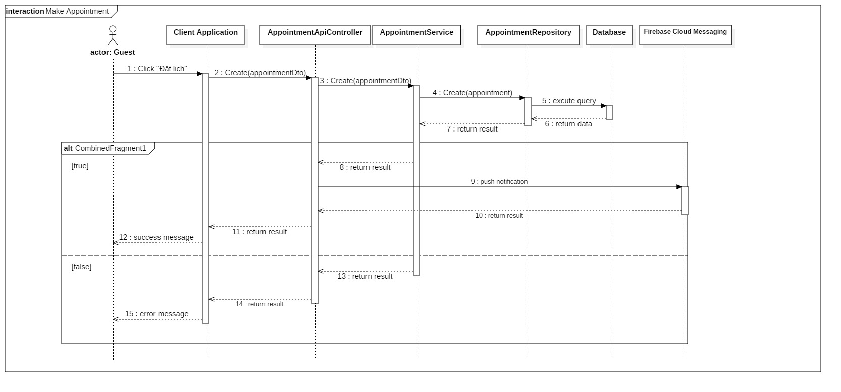

Figure 4 - Sequence Diagram for Make Appointemnt < Guest

#### Patient

##### <Patient> View Appointment’s Test Result

Summary: this diagram shows process for viewing appointment’s test result.

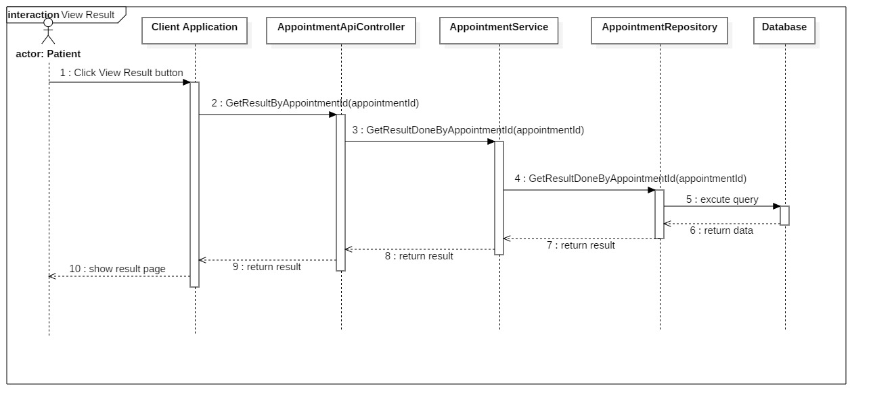

Figure 9 - Sequence Diagram for Accept Auction < Administrator >

### State Machine Diagram

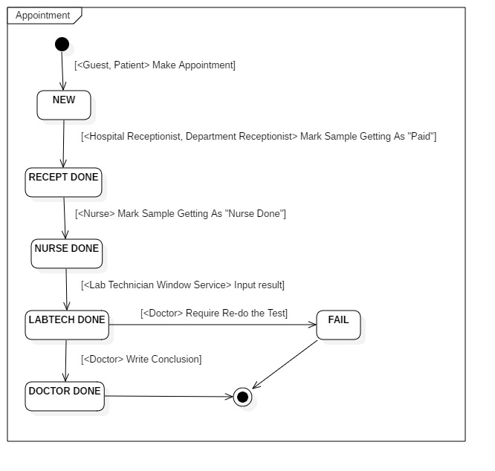

Figure 19 - State Machine Diagram of Appointment

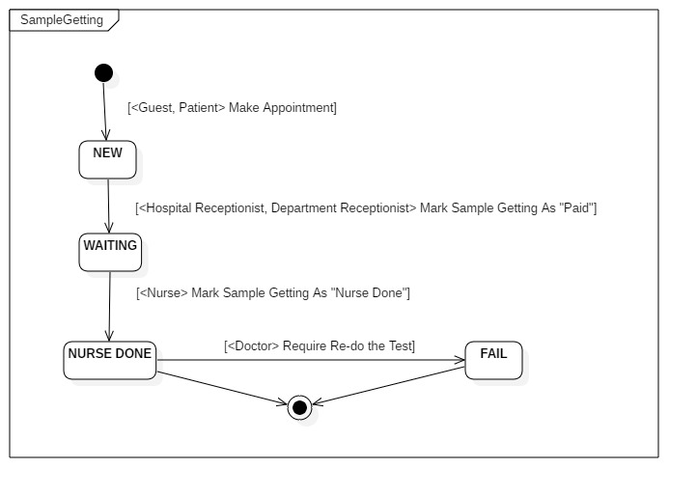

Figure 19 - State Machine Diagram of Sample Gettin

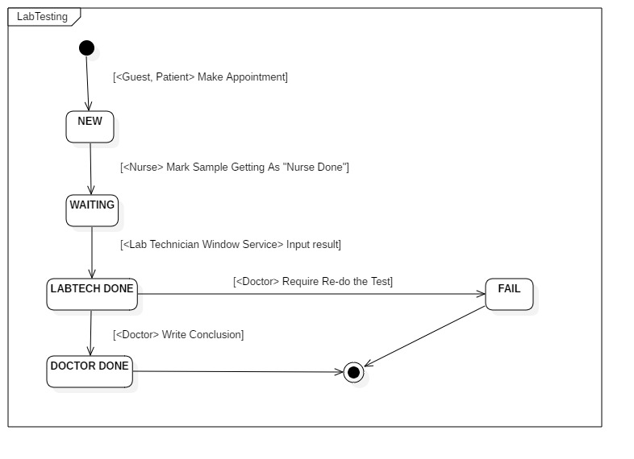

Figure 19 - State Machine Diagram of Lab Testing

## **User Interface Design**

### Web admin application user interface

#### Login Page

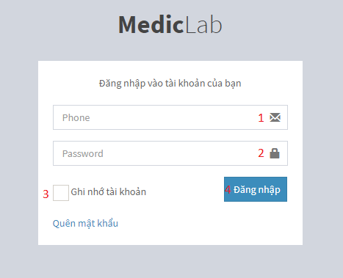

Figure 20 - Web Interface <Login>

**Field**

|  |  |  |  |  |  |  |  |
| --- | --- | --- | --- | --- | --- | --- | --- |
| **No** | **Field Name** | **Description** | **Read only** | **Mandatory** | **Control Type** | **Data Type** | **Length** |
| 1 | Phone | Phone to login | No | Yes | Textbox | String |  |
| 2 | Password | Password to login | No | Yes | Textbox | String |  |
| 3 | Remember me | Auto log in | No | No | Checkbox | Boolean |  |

**Buttons/Hyperlinks:**

|  |  |  |  |  |
| --- | --- | --- | --- | --- |
| **No** | **Function** | **Description** | **Validation** | **Outcome** |
| 4 | Sign In | Login into system | Validate all required fields | Navigate to Admin page |

#### Hospital Receptionist Page

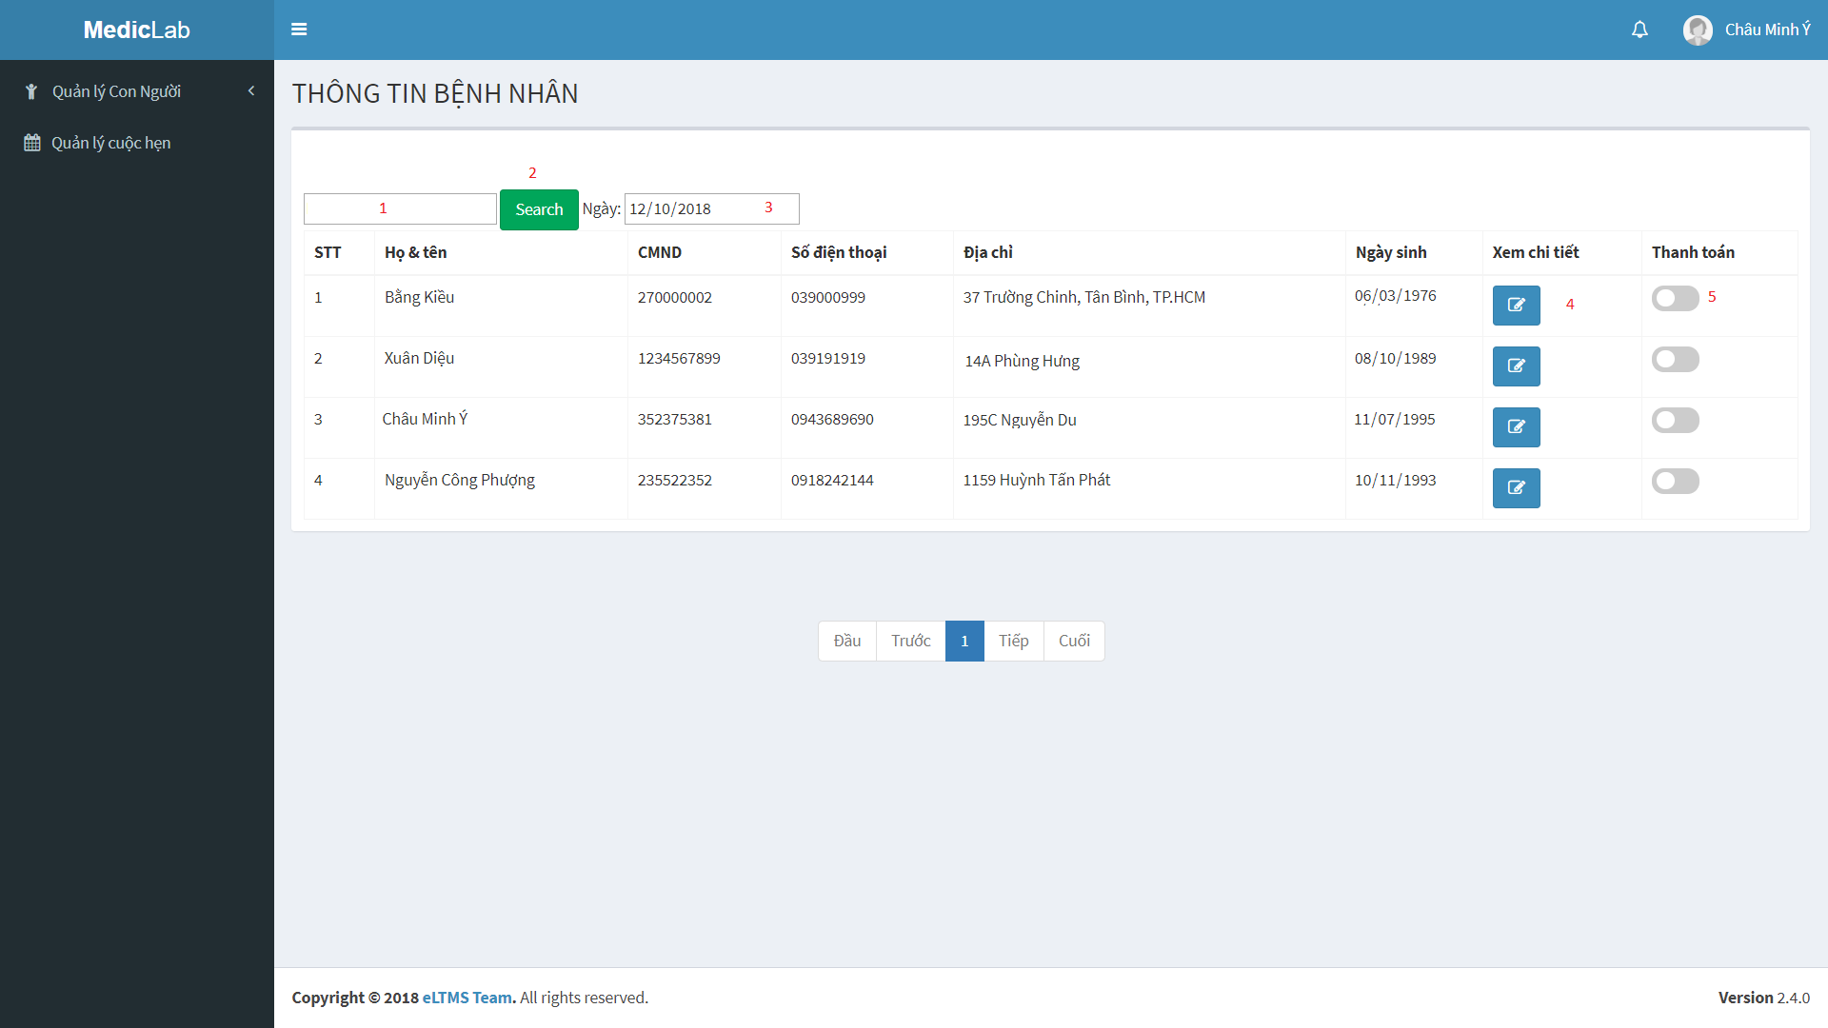

Figure 21 - Admin Web Interface <Hospital Receptionist>

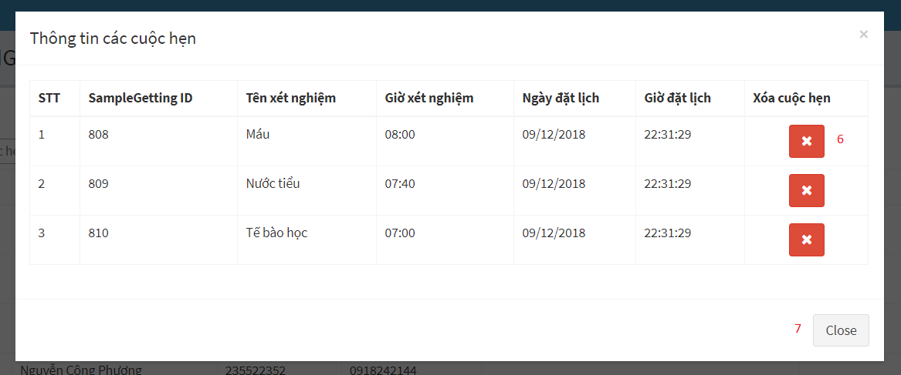

Figure 22 - Admin Web Interface <Hospital Receptionist>

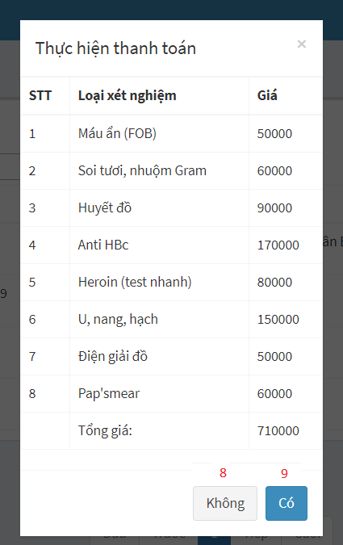

Figure 23 - Admin Web Interface <Hospital Receptionist>

**Field**

|  |  |  |  |  |  |  |  |
| --- | --- | --- | --- | --- | --- | --- | --- |
| **No** | **Field Name** | **Description** | **Read only** | **Mandatory** | **Control Type** | **Data Type** | **Length** |
| 1 | Keyword | Fill keyword to search | No | Yes | Text | String |  |
| 3 | Select Date | Select Date to show Patient | No | Yes | Date | Date |  |

**Buttons/Hyperlinks**

|  |  |  |  |  |
| --- | --- | --- | --- | --- |
| **No** | **Function** | **Description** | **Validation** | **Outcome** |
| 2 | Search | Search after getting keywork | N/A | Show list of patients by keywork |
| 4 | Show details appointment | Show list of appointments | N/A | Show list of appointments |
| 5 | Change status | Show popup for admin to check hospital fee for patient and pay it | N/A | Show list of price and confirm Y/N to change status |
| 6 | Delete sampleGetting | Delete sampleGetting after getting request | N/A | SampleGetting is deleted |
| 7 | Close popup | Close popup details appointment | N/A | Popup is closed |
| 8 | Cancel paying | Confirm payment | N/A | Status is not changed |
| 9 | Accept paying | Confirm payment | N/A | Status is changed |

#### View Department Receptionist Page

# 

Figure 24 - Admin Web Interface <View Department Receptionist>

# 

Figure 25 - Admin Web Interface <View Department Receptionist>

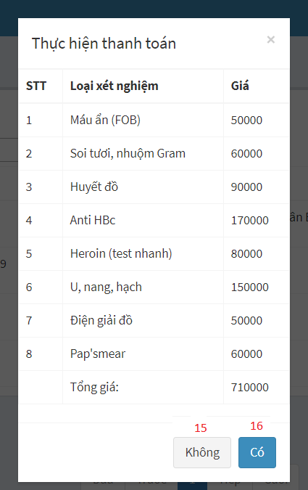

Figure 26 - Admin Web Interface <View Department Receptionist>

**Field**

|  |  |  |  |  |  |  |  |
| --- | --- | --- | --- | --- | --- | --- | --- |
| **No** | **Field Name** | **Description** | **Read only** | **Mandatory** | **Control Type** | **Data Type** | **Length** |
| 2 | Keyword | Fill keyword to search | No | Yes | Text | String |  |
| 4 | Select sample | Select sample to show appointment | No | Yes | Dropdown list | String |  |
| 5 | Select Date | Select date to show appointment | No | Yes | Date | Date |  |
| 7 | Họ và Tên | Patient’s information | No | Yes | Textbox | String |  |
| 8 | CMND | Patient’s information | No | Yes | Textbox | String |  |
| 9 | Ngày sinh | Patient’s information | No | Yes | Date | Date |  |
| 10 | Số điện thoại | Patient’s information | No | Yes | Textbox | String |  |
| 11 | Địa chỉ | Patient’s information | No | Yes | Textbox | String |  |
| 12 | Loại xét nghiệm | Choose labtest | No | Yes | Checkbox | Boolean |  |

**Buttons/Hyperlinks:**

|  |  |  |  |  |
| --- | --- | --- | --- | --- |
| **No** | **Function** | **Description** | **Validation** | **Outcome** |
| 1 | Create appointment | Create appointment for patient | N/A | Show popup appointment’s information |
| 3 | Search | Search after getting keywork | N/A | Show list of appointments by keywork |
| 6 | Change status | Show popup for admin to check hospital fee for patient and pay it | N/A | Show list of price and confirm Y/N to change status |
| 13 | Add a new appointment | Add a new appointment | N/A | A new appointment is created |
| 14 | Close popup | Close popup details appointment | N/A | Popup is closed |
| 15 | Cancel paying | Confirm payment | N/A | Status is not changed |
| 16 | Accept paying | Confirm payment | N/A | Status is changed |

#### View Nurse Page

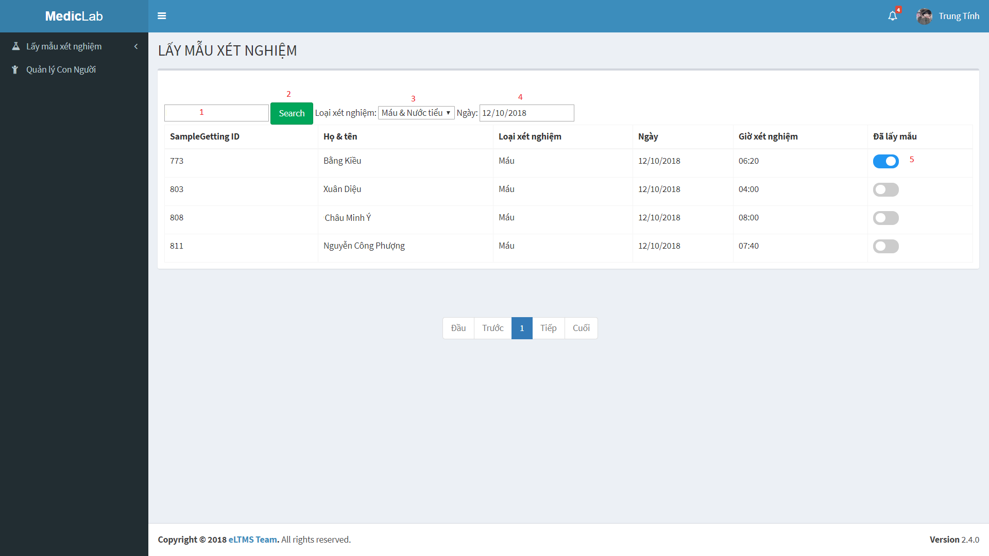

Figure 27 - Admin Web Interface <View Nurse>

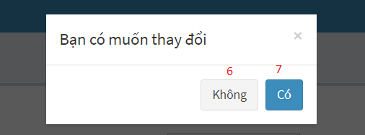

Figure 28 - Admin Web Interface <View Nurse>

**Field**

|  |  |  |  |  |  |  |  |
| --- | --- | --- | --- | --- | --- | --- | --- |
| **No** | **Field Name** | **Description** | **Read only** | **Mandatory** | **Control Type** | **Data Type** | **Length** |
| 1 | Keyword | Fill Keyword to seach | No | Yes | Text | String |  |
| 3 | Select sample | Select sample to show appointment | No | Yes | Dropdown list | String |  |
| 4 | Select Date | Select date to show appointment | No | Yes | Date | Date |  |

**Buttons/Hyperlinks**

|  |  |  |  |  |
| --- | --- | --- | --- | --- |
| **No** | **Function** | **Description** | **Validation** | **Outcome** |
| 2 | Search | Search after getting keywork | N/A | Show list of appointment by keywork |
| 5 | Change status | Show popup for admin to confirm and change status | N/A | Show options to choose Y/N |
| 6 | Cancel action | Choose No | N/A | Status is not changed |
| 7 | Accept action | Choose Yes | N/A | Status is changed |

#### View Laboratory Technician Page

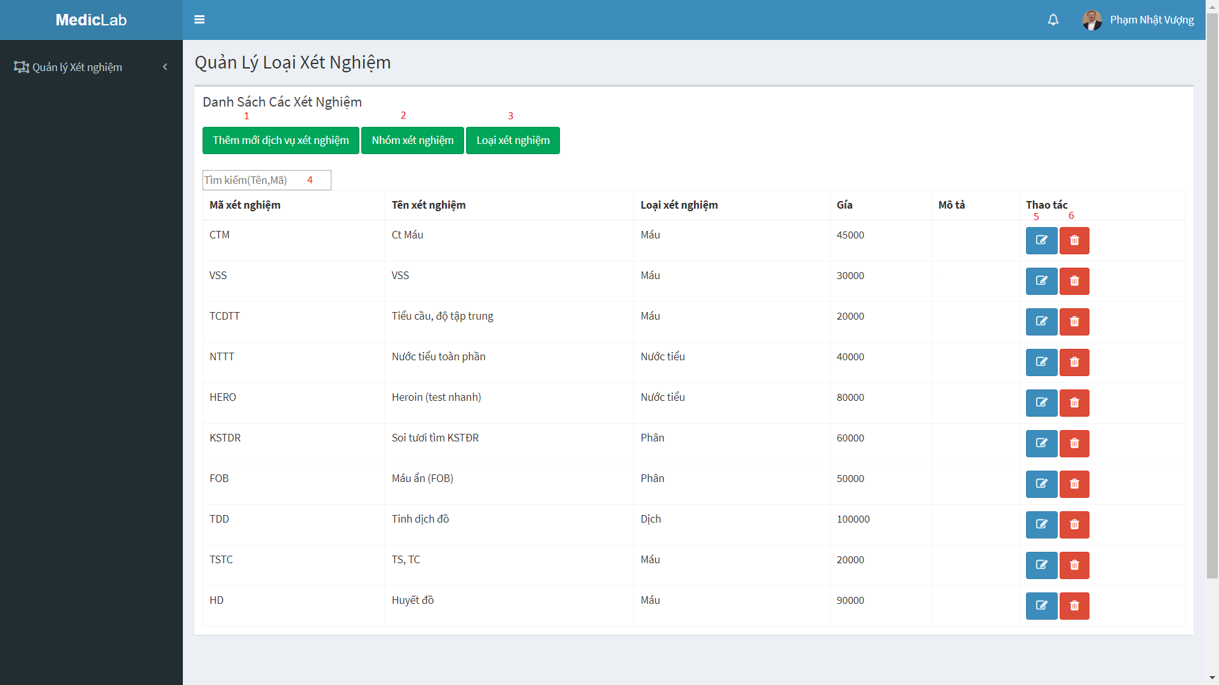

Figure 29 - Admin Web Interface <View Laboratory Technician>

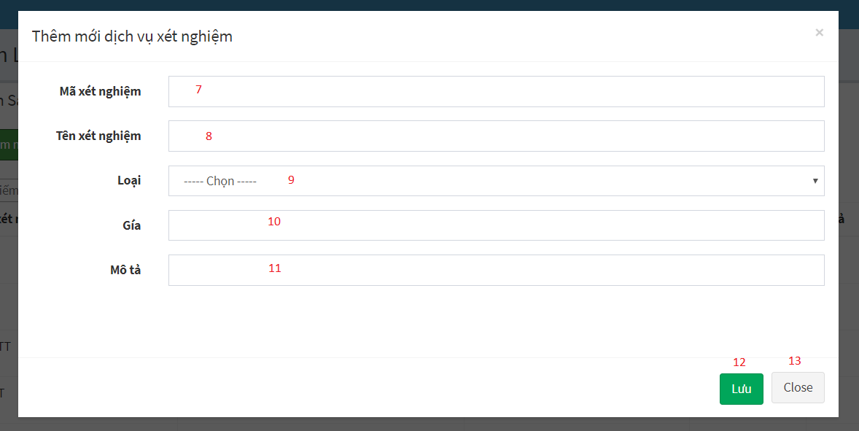

Figure 30 - Admin Web Interface <View Laboratory Technician-Add Labtest>

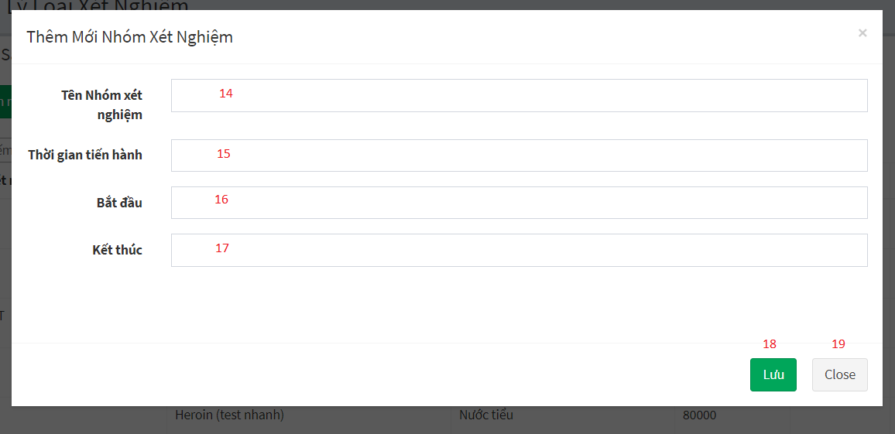

Figure 31 - Admin Web Interface <View Laboratory Technician-Add Sample group>

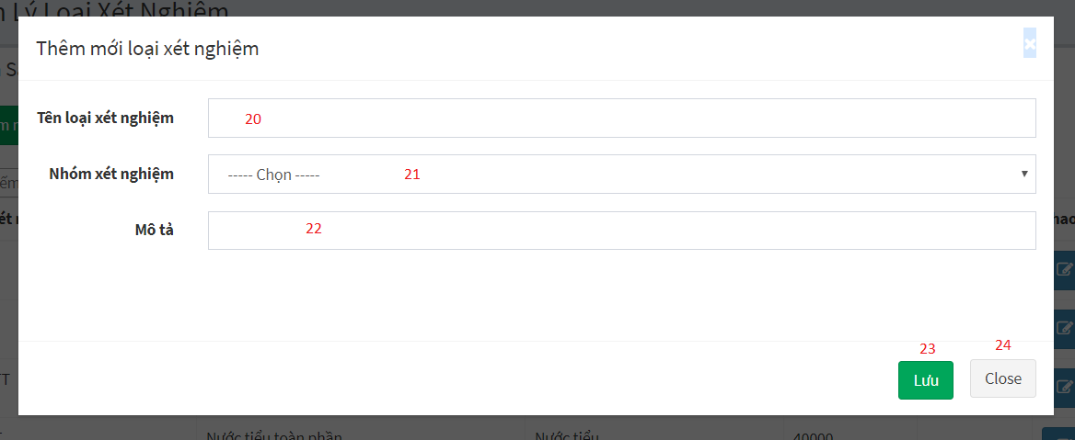

Figure 32 - Admin Web Interface <View Laboratory Technician-Add Sample>

**Field**

|  |  |  |  |  |  |  |  |
| --- | --- | --- | --- | --- | --- | --- | --- |
| **No** | **Field Name** | **Description** | **Read only** | **Mandatory** | **Control Type** | **Data Type** | **Length** |
| 4 | Keyword | Fill keyword to seach | No | Yes | Text | String |  |
| 7 | Mã xét nghiệm | Labtest’s information | No | Yes | Textbox | String |  |
| 8 | Tên xét nghiệm | Labtest’s information | No | Yes | Textbox | String |  |
| 9 | Loại | Labtest’s information | No | Yes | Dropdown list | String |  |
| 10 | Giá | Labtest’s information | No | Yes | Textbox | String |  |
| 11 | Mô tả | Labtest’s information | No | Yes | Textbox | String |  |
| 14 | Tên nhóm xét nghiệm | Sample group’s information | No | Yes | Textbox | String |  |
| 15 | Thời gian tiến hành | Sample group’s information | No | Yes | Textbox | String |  |
| 16 | Bắt đầu | Sample group’s information | No | Yes | Textbox | String |  |
| 17 | Kết thúc | Sample group’s information | No | Yes | Textbox | String |  |
| 20 | Tên loại xét nghiệm | Sample’s information | No | Yes | Textbox | String |  |
| 21 | Nhóm xét nghiệm | Sample’s information | No | Yes | Dropdown list | String |  |
| 22 | Mô tả | Sample’s information | No | Yes | Textbox | String |  |

**Buttons/Hyperlinks**

|  |  |  |  |  |
| --- | --- | --- | --- | --- |
| **No** | **Function** | **Description** | **Validation** | **Outcome** |
| 1 | Add new labtest | Add new labtest | N/A | Show popup to fill information of labtest |
| 2 | Add new sample group | Add new sample group | N/A | Show popup to fill information of sample group |
| 3 | Add new sample | Add new sample | N/A | Show popup to fill information of sample |
| 5 | Edit labtest | Edit information of labtest | N/A | Edit information of labtest |
| 6 | Delete labtest | Delete labtest after getting request | N/A | Labtest is deleted |
| 12 | Add a new labtest | Add a new labtest | N/A | A new labtest is created |
| 13 | Close popup | Close popup | N/A | Popup is closed |
| 18 | Add a new sample group | Add a new sample group | N/A | A new sample group is created |
| 19 | Close popup | Close popup | N/A | Popup is closed |
| 23 | Add a new sample | Add a new sample | N/A | A new sample is created |
| 24 | Close popup | Close popup | N/A | Popup is closed |

#### View Doctor Page

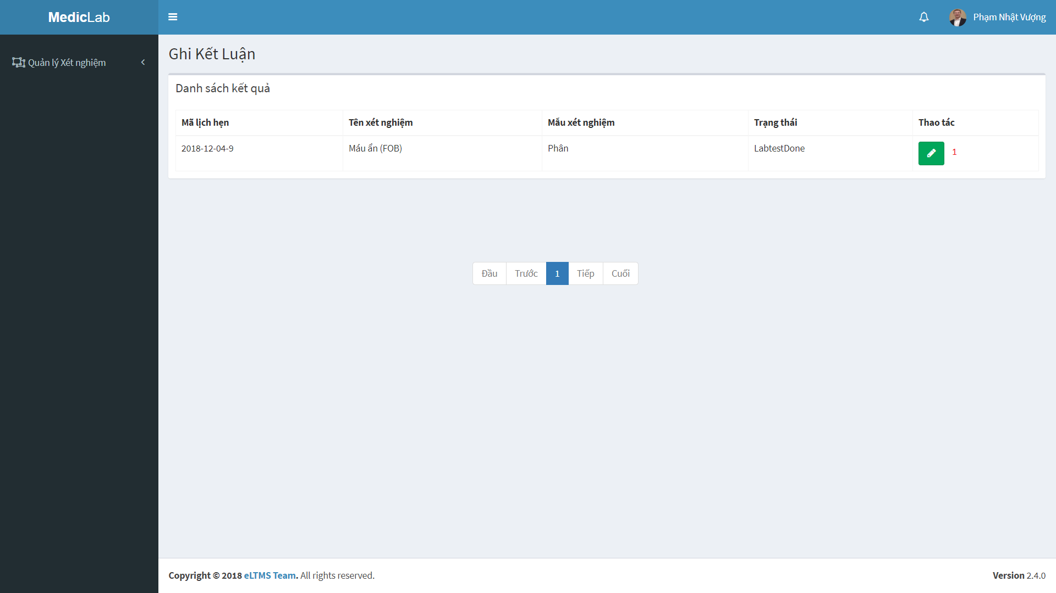

Figure 33 - Admin Web Interface <View Doctor>

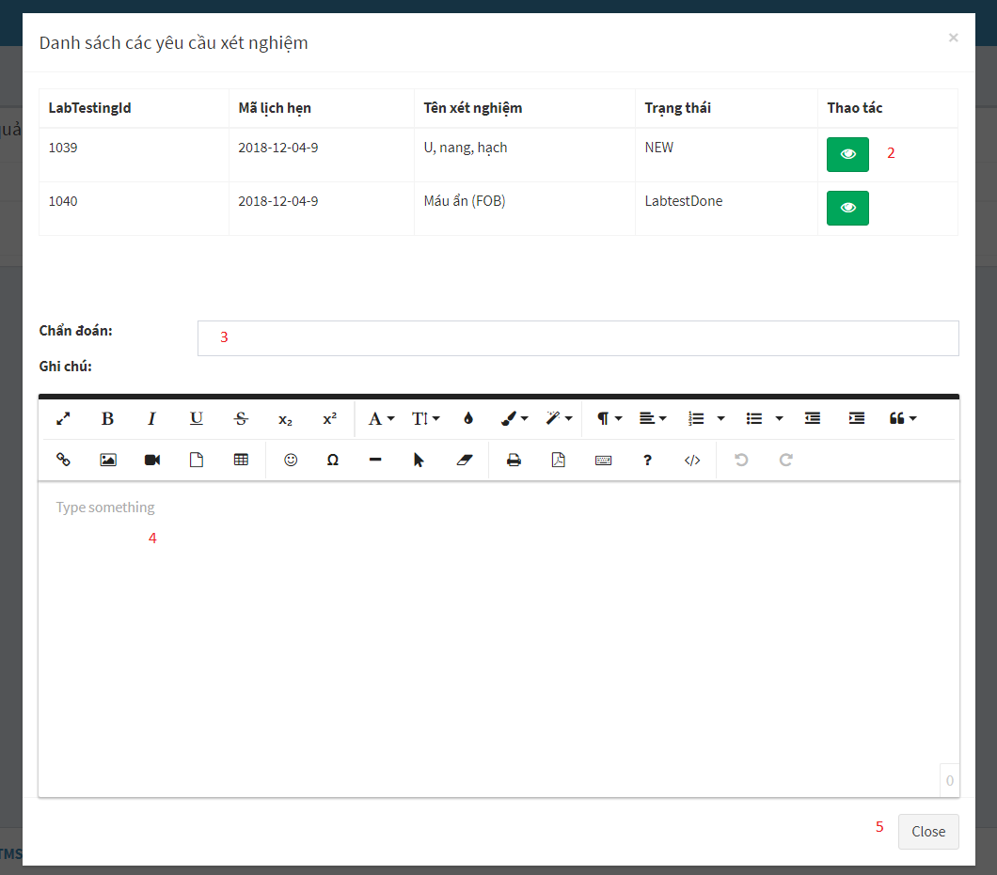

Figure 34 - Admin Web Interface <View Doctor>

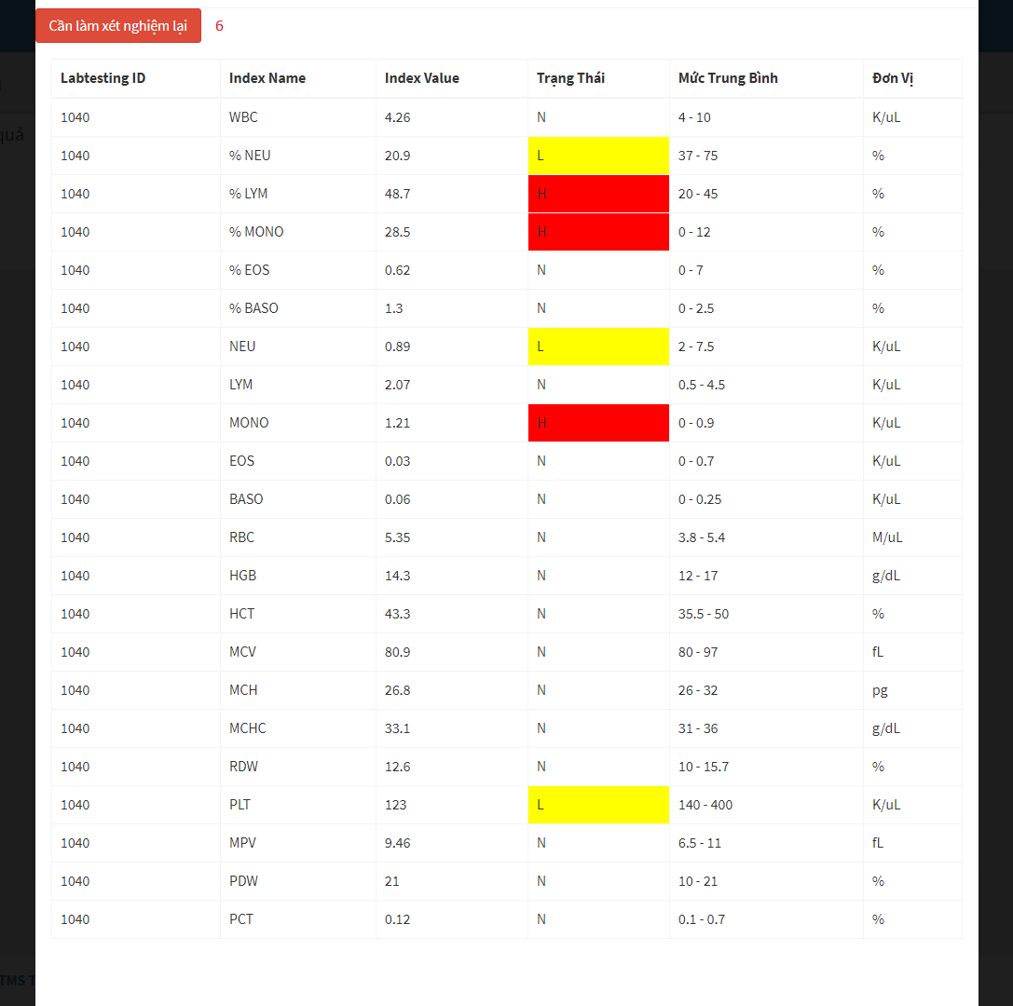

Figure 35 - Admin Web Interface <View Doctor>

**Field**

|  |  |  |  |  |  |  |  |
| --- | --- | --- | --- | --- | --- | --- | --- |
| **No** | **Field Name** | **Description** | **Read only** | **Mandatory** | **Control Type** | **Data Type** | **Length** |
| 3 | Chẩn đoán | Conclusion of doctor | No | Yes | Textbox | String |  |
| 4 | Ghi chú | Note of doctor | No | Yes | Textbox | String |  |

**Buttons/Hyperlinks**

|  |  |  |  |  |
| --- | --- | --- | --- | --- |
| **No** | **Function** | **Description** | **Validation** | **Outcome** |
| 1 | Check for disease | View testing result, write note and conclusion | N/A | Show popup with testing result, space to write note and conclusion |
| 2 | View testing result | View testing result | N/A | Show popup with the details of testing result |
| 5 | Close popup | Close popup | N/A | Popup is closed |
| 6 | Request re-testing | Request re-testing when doctor see something wrong about testing result | N/A | Send request re-testing to patient |

### Web application user interface

#### Login



Figure 36 - Web Interface <Login>

**Field**

|  |  |  |  |  |  |  |  |
| --- | --- | --- | --- | --- | --- | --- | --- |
| **No** | **Field Name** | **Description** | **Read only** | **Mandatory** | **Control Type** | **Data Type** | **Length** |
| 1 | Phone | Phone to login | No | Yes | Textbox | String |  |
| 2 | Password | Password to login | No | Yes | Textbox | String |  |
| 3 | Remember me | Auto log in | No | No | Checkbox | Boolean |  |

**Buttons/Hyperlinks:**

|  |  |  |  |  |
| --- | --- | --- | --- | --- |
| **No** | **Function** | **Description** | **Validation** | **Outcome** |
| 4 | Sign In | Login into system | Validate all required fields | Navigate to User page |

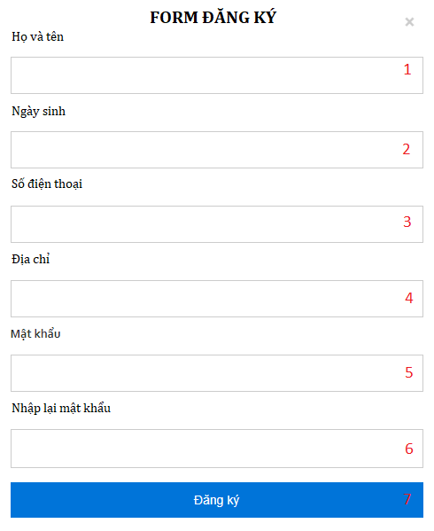

Figure 27 - Web Interface <Register account>

**Field**

|  |  |  |  |  |  |  |  |
| --- | --- | --- | --- | --- | --- | --- | --- |
| **No** | **Field Name** | **Description** | **Read only** | **Mandatory** | **Control Type** | **Data Type** | **Length** |
| 1 | Username | Patient’s information | No | Yes | Text | String |  |
| 2 | DateOfBirth | Patient’s information | No | Yes | Date | Date |  |
| 3 | Phone | Patient’s information | No | Yes | Text | String |  |
| 4 | Address | Patient’s information | No | Yes | Text | String |  |
| 5 | Password | Patient’s information | No | Yes | Password | String |  |
| 6 | PasswordConfirm | Patient’s information | No | Yes | Password | String |  |

**Buttons/Hyperlinks:**

|  |  |  |  |  |
| --- | --- | --- | --- | --- |
| **No** | **Function** | **Description** | **Validation** | **Outcome** |
| 7 | Register | Click to register | N/A | Navigate to Home page |

#### Nav Bar

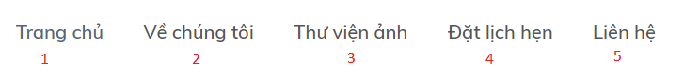

Figure 38 - Web Interface <Menu bar and Categories>

**Buttons/Hyperlinks:**

|  |  |  |  |  |
| --- | --- | --- | --- | --- |
| **No** | **Function** | **Description** | **Validation** | **Outcome** |
| 1 | Navigate to Home Page | N/A | N/A | Navigate to Home Page |
| 2 | Navigate to Introduction Page | Show list of categories as a drop down list | N/A | Navigate to Introduction Page |
| 3 | Navigate to Photo Library Page | N/A | N/A | Navigate to Photo Library Page |
| 4 | Navigate to Book Appointment Page | N/A | N/A | Navigate to Book Appointment Page |
| 5 | Navigate to Contact us | N/A | N/A | Navigate to Contact us |

#### Home Page

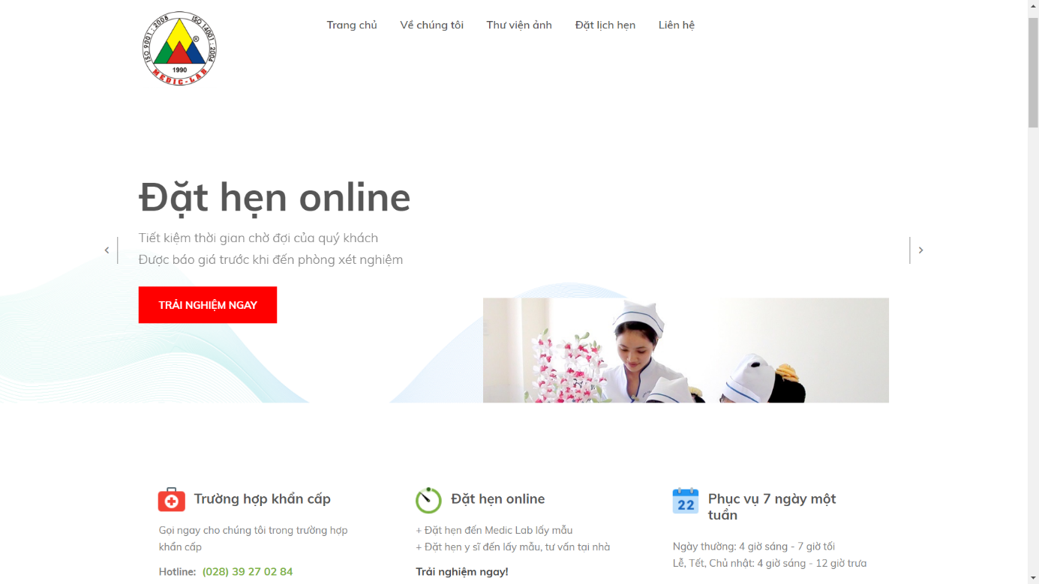

Figure 39 - Web Interface <Home page>

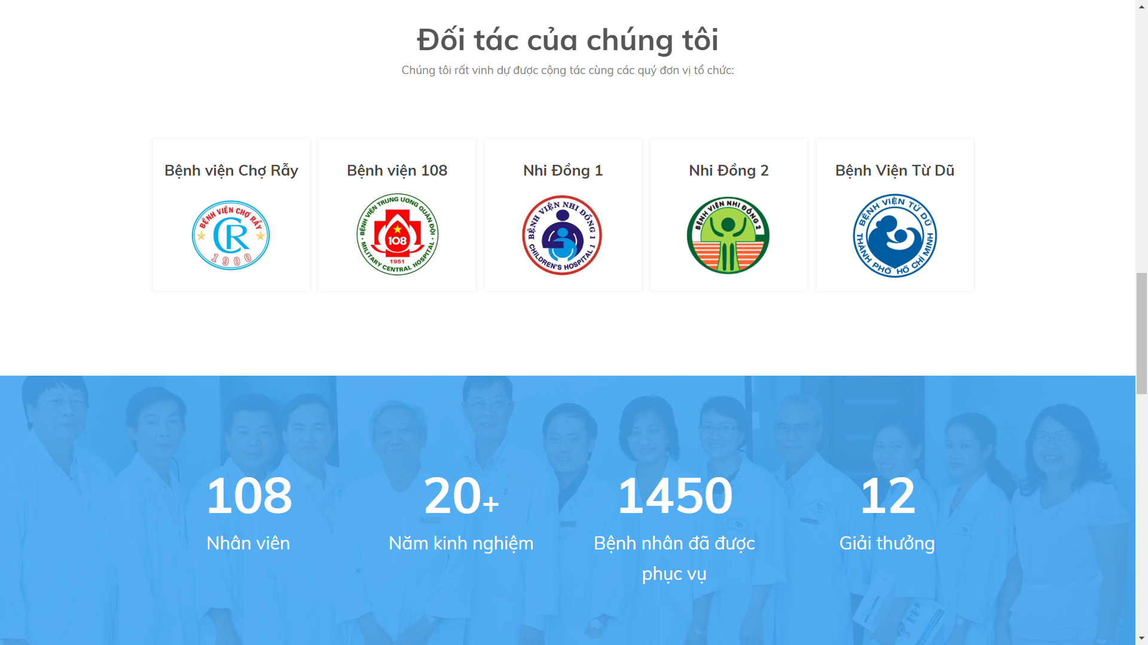

Figure 40 - Web Interface <Home page – Our partner>

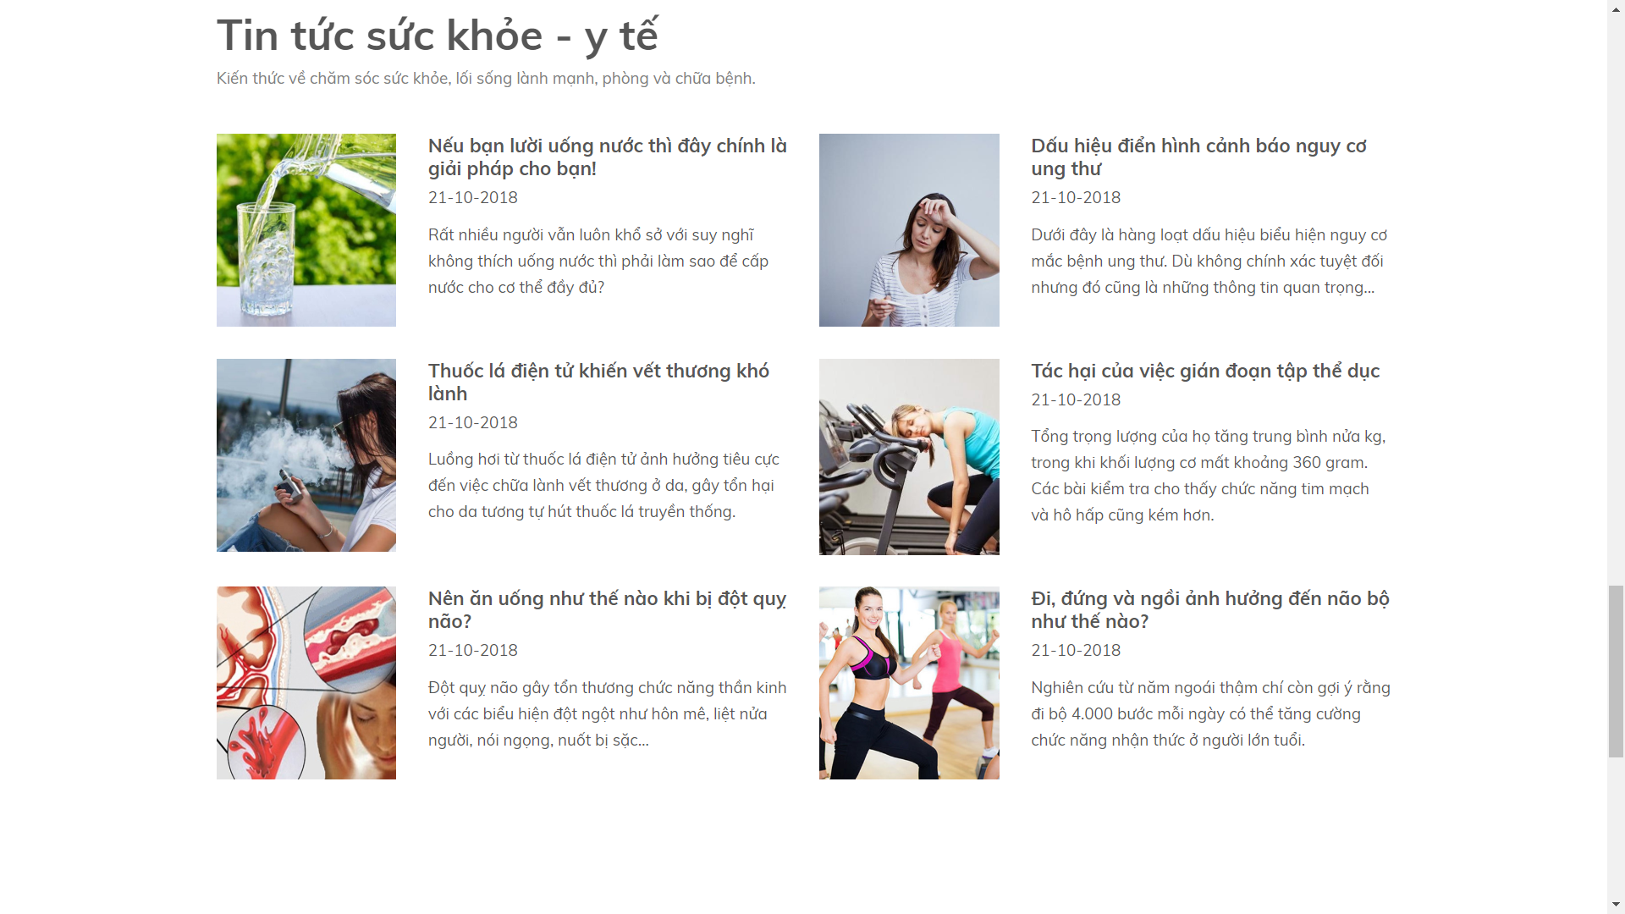

Figure 41 - Web Interface <Home page - News>

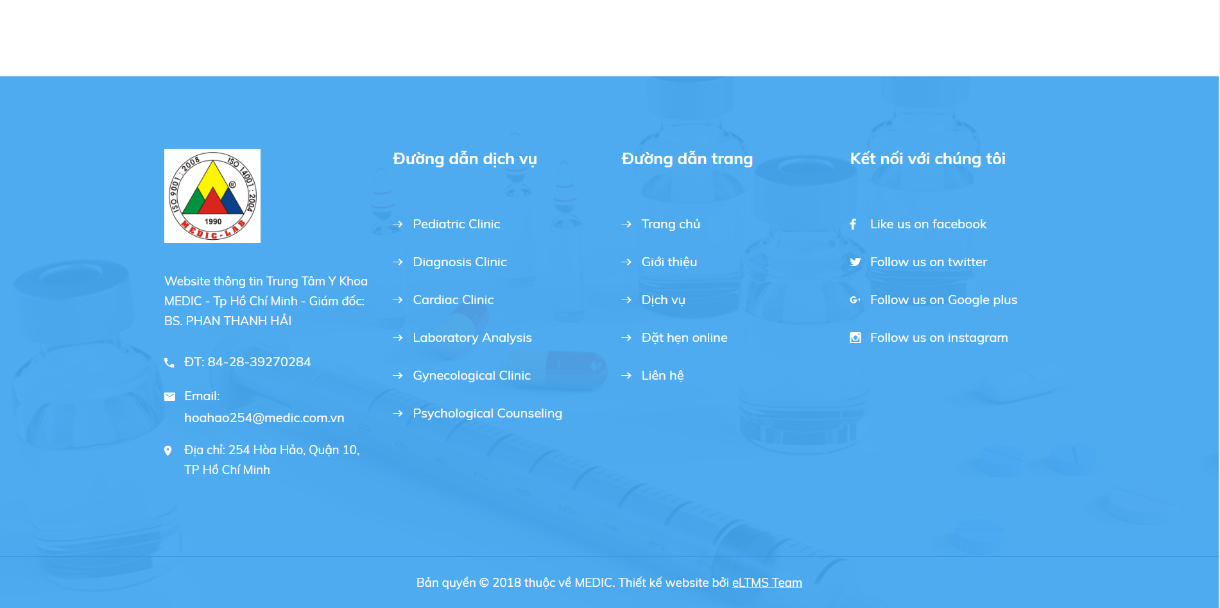

Figure 42 - Web Interface <Home page – Contact us >

#### Book Appointment

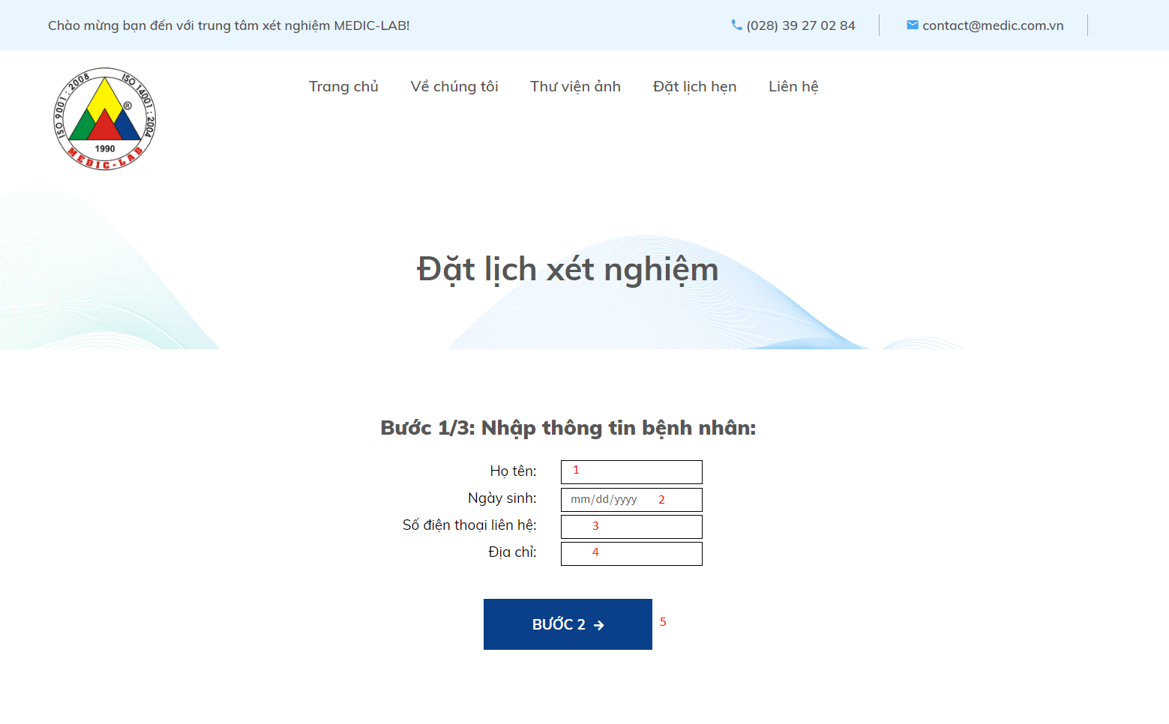

Figure 43 - Web Interface <Book Appointment>

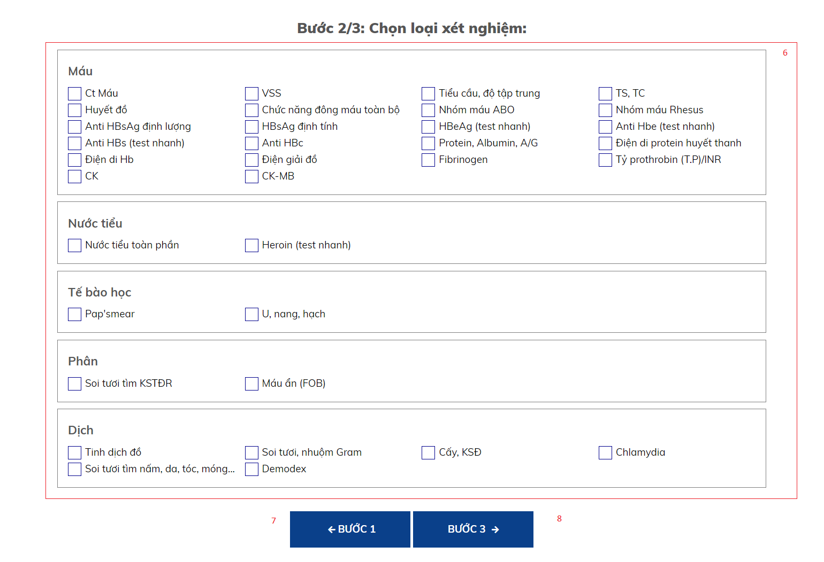

Figure 44 - Web Interface <Book Appointment>

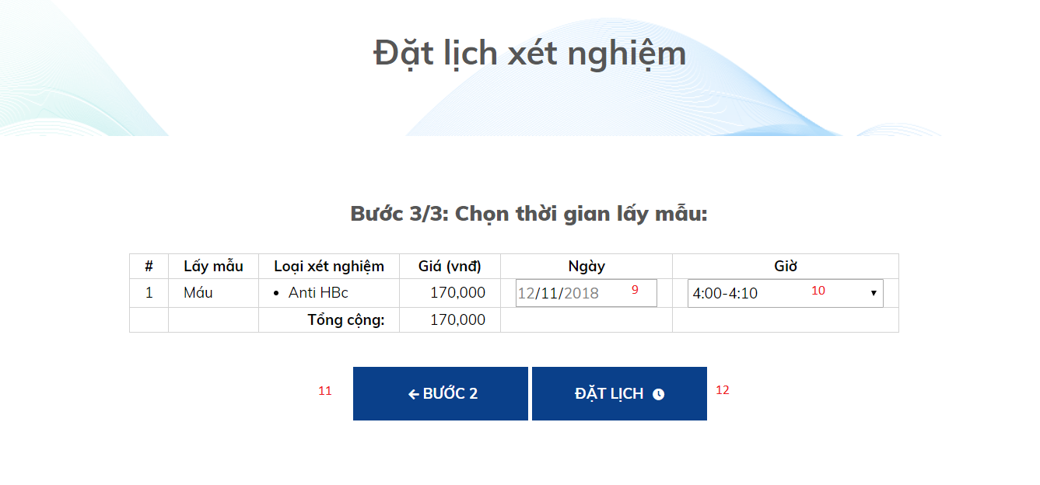

Figure 45 - Web Interface <Book Appointment>

**Field**

|  |  |  |  |  |  |  |  |
| --- | --- | --- | --- | --- | --- | --- | --- |
| **No** | **Field Name** | **Description** | **Read only** | **Mandatory** | **Control Type** | **Data Type** | **Length** |
| 1 | Họ và Tên | Patient’s information | No | Yes | Textbox | String |  |
| 2 | Ngày sinh | Patient’s information | No | Yes | Date | Date |  |
| 3 | Số điện thoại | Patient’s information | No | Yes | Textbox | String |  |
| 4 | Địa chỉ | Patient’s information | No | Yes | Textbox | String |  |
| 6 | Loại xét nghiệm | Choose labtest | No | Yes | Checkbox | Boolean |  |
| 9 | Ngày | Choose approriate time to test | No | Yes | Dropdown list | String |  |
| 10 | Giờ | Choose approriate time to test | No | Yes | Dropdown list | String |  |

**Buttons/Hyperlinks**

|  |  |  |  |  |
| --- | --- | --- | --- | --- |
| **No** | **Function** | **Description** | **Validation** | **Outcome** |
| 5 | Go to step 2 | Click “Bước 2” to go to step 2 | Validate all required fields | Go to step 2 |
| 7 | Go back to step 1 | Click “Bước 1” to go back to step 1 | N/A | Go back to step 1 |
| 8 | Go to step 3 | Click “Bước 3” to go to step 3 | Choose a least one labtest | Go to step 3 |
| 11 | Go back to step 2 | Click “Bước 2” to go back to step 2 | N/A | Go back to step 2 |
| 12 | Submit | Complete booking a new appointment | Validate all required fields | Booking successfully |

#### View list of Booked Appoinments



Figure 46 - Web Interface <View list of booked Appointments>

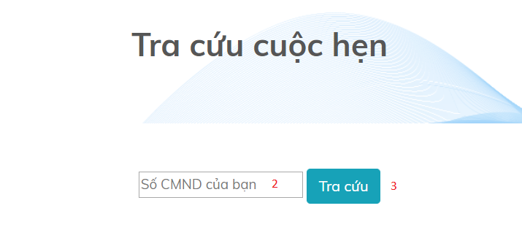

Figure 47 - Web Interface <View list of booked Appointments>

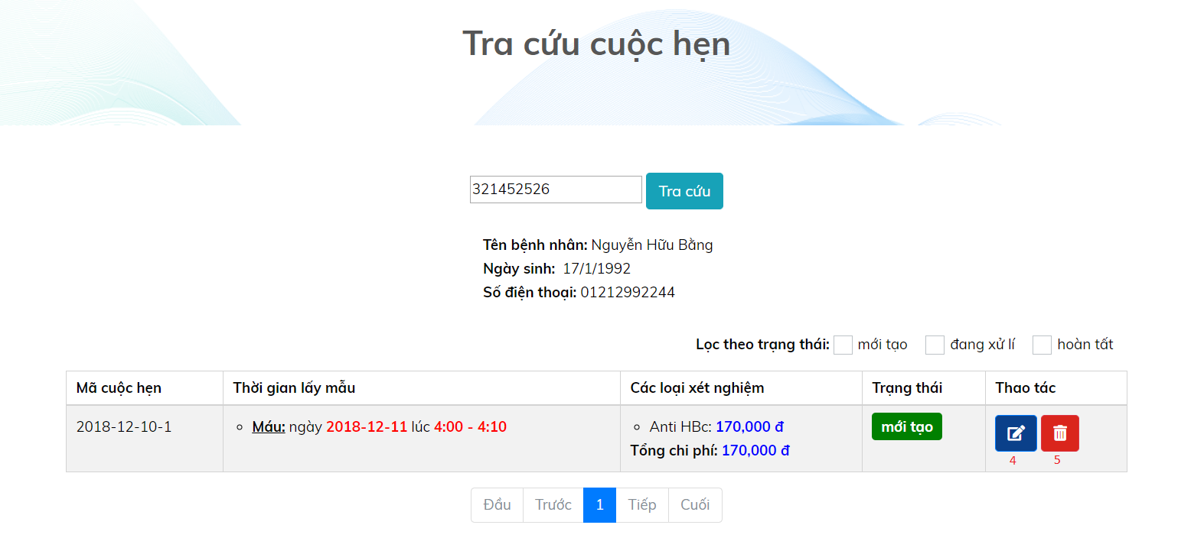

Figure 48 - Web Interface <View list of booked Appointments>

**Field**

|  |  |  |  |  |  |  |  |
| --- | --- | --- | --- | --- | --- | --- | --- |
| **No** | **Field Name** | **Description** | **Read only** | **Mandatory** | **Control Type** | **Data Type** | **Length** |
| 2 | CMND | Input id into textbox area | No | No | Text | String |  |

**Buttons/Hyperlinks**

|  |  |  |  |  |
| --- | --- | --- | --- | --- |
| **No** | **Function** | **Description** | **Validation** | **Outcome** |
| 1 | Navigate to Auctions by View Appointment Page | When user clicks on the link, navigate to a page showing textbox to fill id | N/A | Navigate to a page show textbox to fill id of patient |
| 3 | Search | Click “Tra cứu” to get result from system | N/A | Go to View Appointment Page |
| 4 | Edit appointment | Edit time, sample, labtest for appointment | N/A | Patient’s appointment will be updated |
| 5 | Delete appointment | Delete appointment | N/A | Appointment is deleted |

Figure 36 - Web Interface < Categories bar and sort>

#### View Testing Result

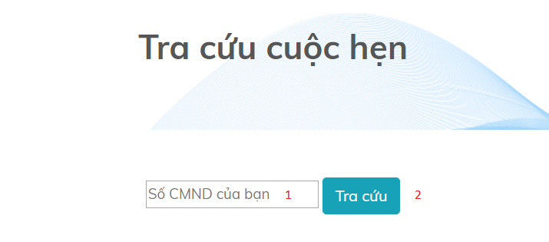

Figure 49 - Web Interface <View Testing Result>

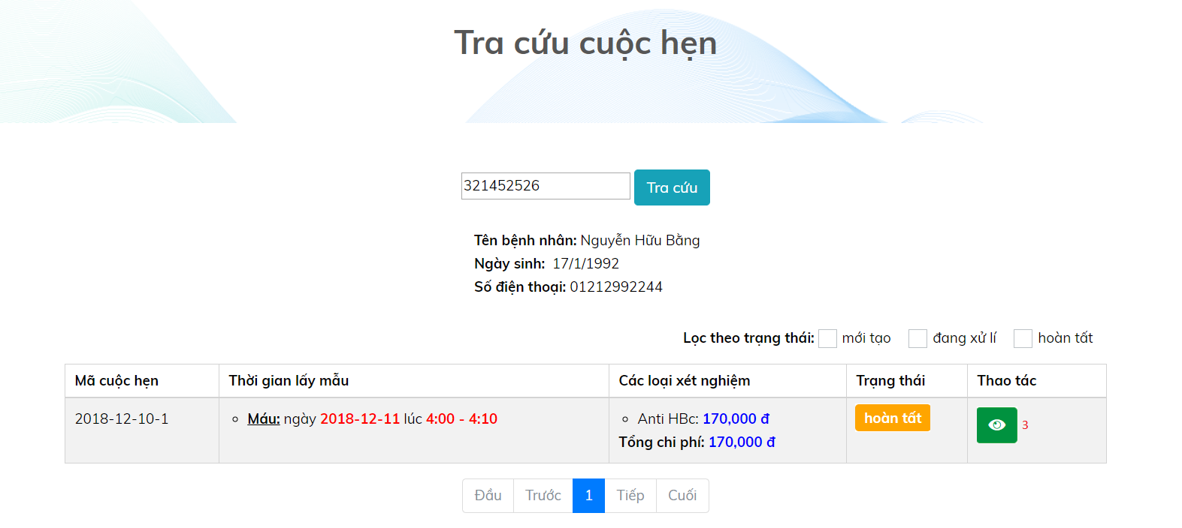

Figure 50 - Web Interface <View Testing Result>

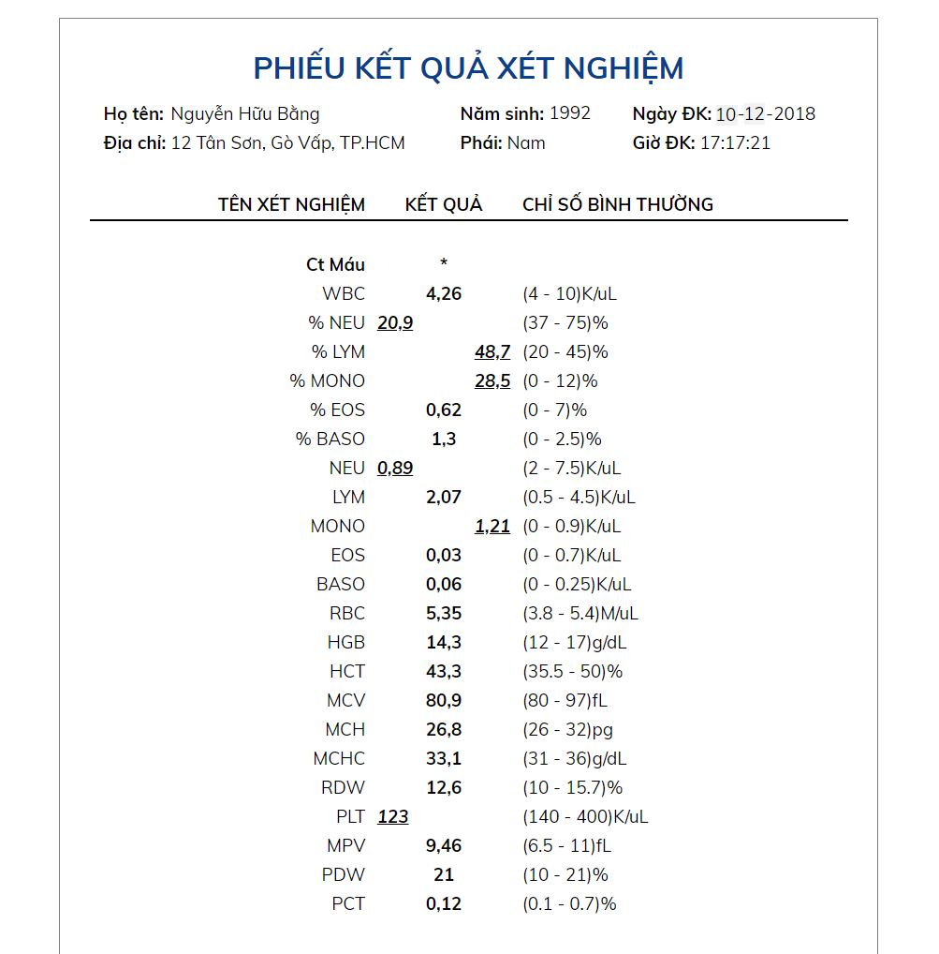

Figure 51 - Web Interface <View Testing Result>

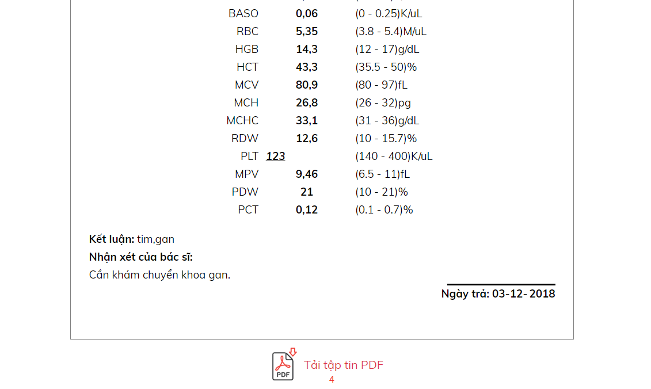

Figure 52 - Web Interface <View Testing Result>

**Field**

|  |  |  |  |  |  |  |  |
| --- | --- | --- | --- | --- | --- | --- | --- |
| **No** | **Field Name** | **Description** | **Read only** | **Mandatory** | **Control Type** | **Data Type** | **Length** |
| 1 | CMND | Input id into textbox area | No | No | Text | String |  |

**Buttons/Hyperlinks**

|  |  |  |  |  |
| --- | --- | --- | --- | --- |
| **No** | **Function** | **Description** | **Validation** | **Outcome** |
| 2 | Search | Click “Tra cứu” to get result from system | N/A | Go to View Appointment Page |
| 3 | View testing result | View testing result | N/A | Go to Result Appointment Page |
| 4 | Download testing result | User can download testing result file as pdf file | N/A | Testing result file will be downloaded |

### Mobile application user interface

#### Login page

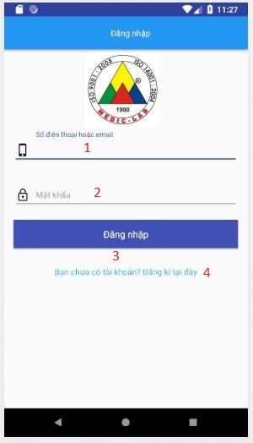

Figure 53 - Mobile Interface <Login>

**Field**

|  |  |  |  |  |  |  |  |
| --- | --- | --- | --- | --- | --- | --- | --- |
| **No** | **Field Name** | **Description** | **Read only** | **Mandatory** | **Control Type** | **Data Type** | **Length** |
| 1 | Phone | Phone to login | No | Yes | Textbox | String |  |
| 2 | Password | Password to login | No | Yes | Textbox | String |  |

**Buttons/Hyperlinks:**

|  |  |  |  |  |
| --- | --- | --- | --- | --- |
| **No** | **Function** | **Description** | **Validation** | **Outcome** |
| 3 | Sign In | Login into system | Validate all required fields | Navigate to Home page |
| 4 | Navigate to Register Page | N/A | N/A | Navigate to Register Page |

#### Register Account page

Figure 55 - Mobile Interface <Register account>

**Field**

|  |  |  |  |  |  |  |  |
| --- | --- | --- | --- | --- | --- | --- | --- |
| **No** | **Field Name** | **Description** | **Read only** | **Mandatory** | **Control Type** | **Data Type** | **Length** |
| 1 | Username | Username to register | No | Yes | Textbox | String |  |
| 2 | Phone | Phone to register | No | Yes | Textbox | String |  |
| 3 | Email | Email to register | No | Yes | Textbox | String |  |
| 4 | Full name | Fullname to register | No | Yes | Textbox | String |  |
| 5 | Date of Birth | D.O.B to register | No | Yes | Datepicker | Date |  |
| 6 | Password | Password to register | No | Yes | Textbox | String |  |
| 7 | Re-Password | Re-Password to confirm password | No | Yes | Textbox | String |  |

**Buttons/Hyperlinks:**

|  |  |  |  |  |
| --- | --- | --- | --- | --- |
| **No** | **Function** | **Description** | **Validation** | **Outcome** |
| 8 | Register | Register into system | Validate all required fields | Navigate to Phone verify page, then navigate to Login Page |
| 9 | Navigate to Login Page | N/A | N/A | Navigate to Login Page |

## **Database Design**

### Entity relationship diagram (ERD)

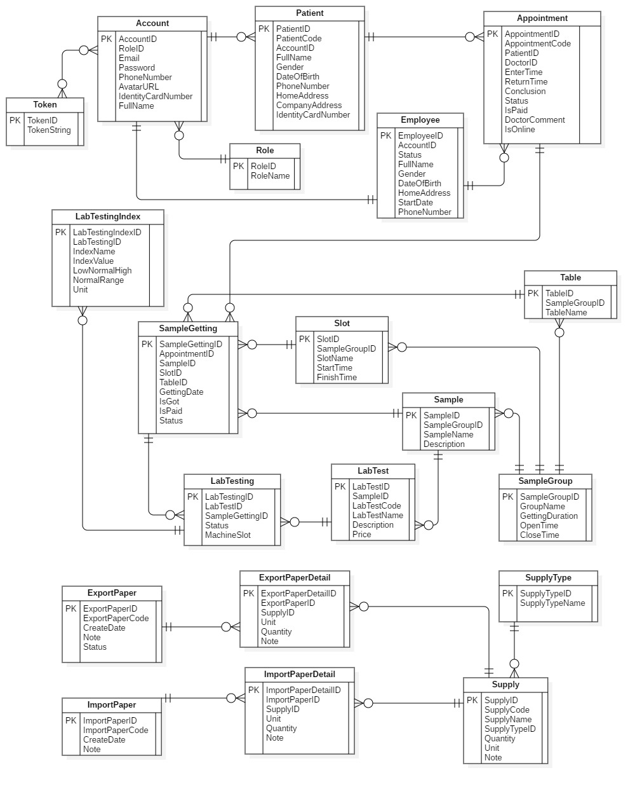

Figure 67 - Entity relationship diagram (ERD)

### Entity dictionary

|  |  |
| --- | --- |
| Entity Data Dictionary: describe content of all entities | |
| **Entity name** | **Description** |
| Account | Contain account information |
| Appointment | Contain Appointment information |
| Employee | Contain staff’s information |
| ExportPaper | Contain ExportPaper information |
| ExportPaperDetail | Contain ExportPaperDetail information |
| ImportPaper | Contain information about ImportPaper |
| ImportPaperDetail | Contain ImportPaperDetail information |
| LabTest | Contain LabTest information |
| LabTesting | Contain information about LabTesting |
| LabTestingIndex | Contain transaction information of LabTestingIndex |
| Patient | Contain Patient information |
| Role | Contain Role information |
| Sample | Contain Sample information |
| SampleGetting | Contain SampleGetting information |
| SampleGroup | Contain SampleGroup information |
| Slot | Contain Slot information |
| Supply | Contain Supply information |
| SupplyType | Contain SupplyType information |
| Table | Contain Table information |
| Token | Contain Token information |

Table 14 - Entity dictionary

## **Algorithms**

### Slot Suggestion

#### Definition

Generate the set of samples getting slots which has minimum total time.

#### Define problem

- When create a new appointment, user often have to spend a lot of effort to choose the suitable slots. Then, there is a need for an automatic solution using algorithms.

- There are N sample-gettings that the patient needs to perform. (blood getting, urine getting, are sample-gettings)

- Each room has a set of slots which have the same durations. Different sample getting rooms can have different slot durations.

- Assume that patients need to do all sample-gettings that they chosed in ONE day, so that the total time is minimum.

#### Solution

We use permutation recursive permutation and dynamic programming (DP) to solve this problem. We follow 2 steps:

* Step 1: Consider each permutation of N sample getting rooms in order, we use DP to calculate the optimized set of slots in the order of sample-gettings.
* Step 2: DP Formula:
* Assume that T[i][j].StartTime: the start time of the j-slot in the i-th slot set. (the i-th slot set belongs to the i-th sample getting).
* Assume that T[i][j].FinishTime: the finish time.
* Assume that dp[i][j] is the minimum waiting time (between slots of sample gettings) if the last sample-getting is the i-th one and the it’s chosed slot is the j-th slot. i is from 0 to N-1, j is from 0 to Length of i-th slot set – 1. Because the sample-gettings’ duration is fixed, the order, which has the minimum waiting time, has the minimum total time.
* dp[i][j] = min {dp[i-1][k] + (T[i-1][k].StartTime – T[i][j].FinishTime) | T[i-1][k].StartTime – T[i][j].FinishTime > 0}.
* Base: dp[0][j] = T[0][j] – comingTime. (comingTime: the time that the patient arrives at the hospital).
* The result of problem is min {dp[n-1][j]}.
* Step 3: Trace to get the optimized order of slots.

#### Complexity

The complexity of this algorithm is **O(N! * N3). In which, N is the number of selected Samples of a patient on a day.**

#### Flowchart

